**Practical No. 1**

1 **Aim- Understanding the Sensor Node Hardware.**

A wireless sensor network (WSN) is a hardware and software package that typically consists of four parts (see Figure 1):

a) ‘Sensors’ connected to each node by a wired connection. In our case, we use sensors that can measure soil moisture, electrical conductivity, soil temperature,water pressure, flow rate, or a range of weather variables (light, air temperature,wind, humidity, etc.).

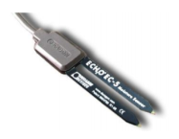

Figure 2. One of many sensors that can be connected to a node, this EC-5 sensor (Decagon Devices, Inc. Pullman, WA) measures volumetric water content (soil moisture).

b) ‘Nodes’ collect the data from sensors and transmit that to a ‘base station’ computer using a one way (in the case of monitoring) or two-way (in the case of monitoring and control) radio. Nodes can simply monitor environmental and soil conditions or can be used to make control decisions. For example, some nodes have the capability to control an electric valve, such as an irrigation valve.

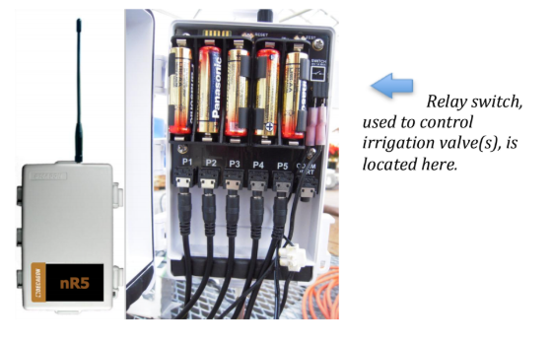

Figure 3. This nR5 (Decagon Devices, Inc. Pullman, WA) node is powered off of 5-AA batteries and is connected to 5 soil moisture sensors via stereo ports. The nR5 node is also capable of controlling irrigation valve(s), based on user-defined settings.

c) ‘Base Station’ computer connects the system to the internet, so that data collected by the nodes, then transmitted to the base station computer, can be viewed anywhere an internet connection is available.

d) ‘Graphical User Interface’ is the web-based software package, that allows the data collected by sensors to be viewed. The software is also used to set irrigation parameters.

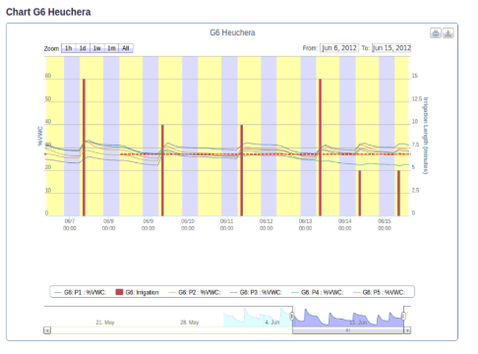

Figure 4. The graphical user interface above depicts the volumetric water content (soil moisture) as horizontal lines and irrigation events and amounts as bars. Notice the increase in soil moisture after each irrigation event.

Not every WSN will have all four components, but to get optimal functionality the systems developed as part of this project do.

A very simple WSN example that many can relate to is that of the wireless environmental monitoring system used by the National Weather Service (NWS). You have probably seen these at a local airport or school. In this case, sensors measure environmental conditions and send this data to a node that wirelessly transmits the data using a cell signal or wireless signal to a base-station computer where NWS employees (and you) can view the current temperature (or rainfall/dew point, wind, etc.) via a website or application (‘app’).

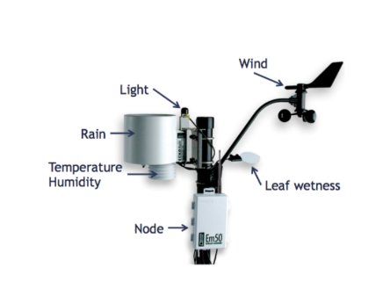

Figure 5. Typical environmental monitoring sensors that you would see at a National Weather Service (NWS) monitoring station. These same components can be used in a wireless sensor network by a specialty crop producer.